# Sensor

Ok first of all, we will talk about sensors we had 3 options:

1) IR sensor : It’s a really famous sensor used in competition, cheep and works with infared but it’s a little slow

2) ToF: it uses lighr as a signal which make it vonurable to any bright environment, but it’svery fast

3) Ultra sonic: It’s cheep uses sound, but it’s slow and has a big size

So after comparing each sensor we decided to use the IR as we don’t garnetee a free bright environment

About the placement we will use 5 IRs in this shape:

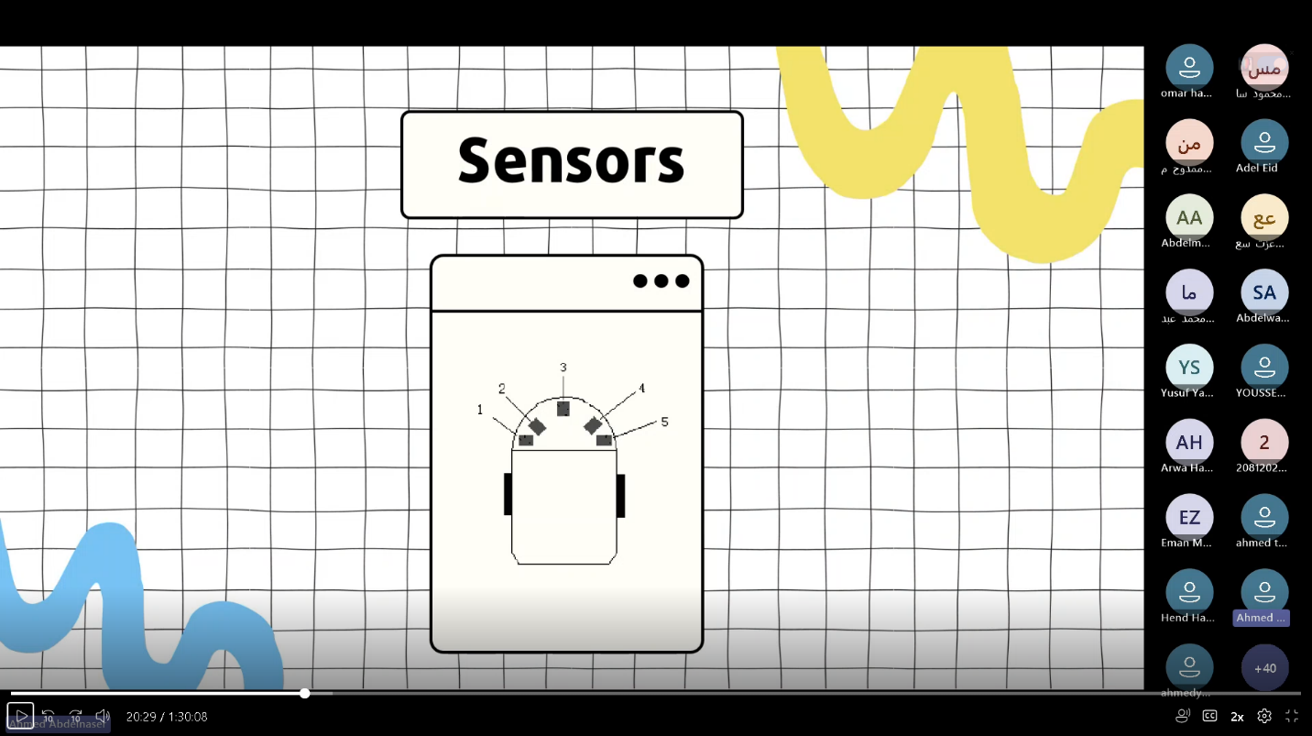

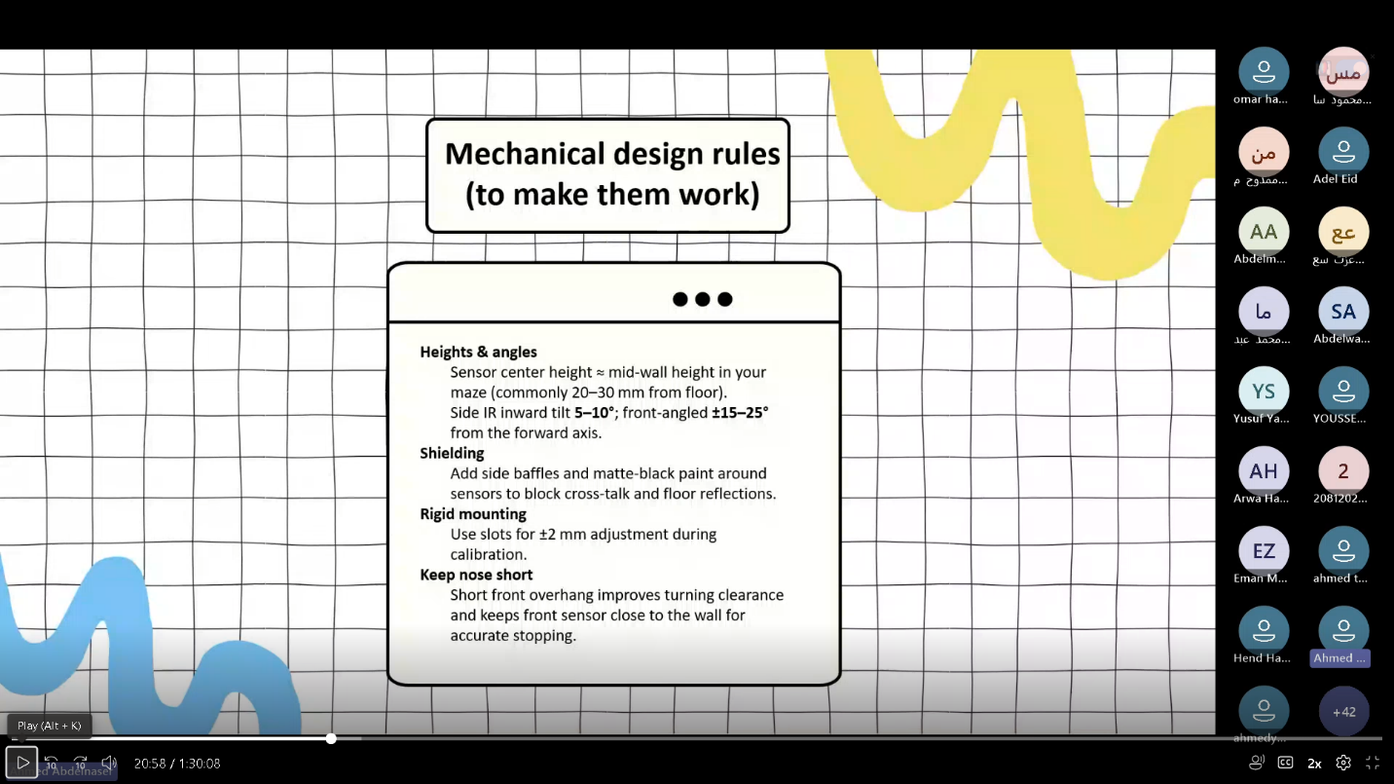With this rules:

Making sure that we don’t put any refelective material such as aluminum so it don’t miss with the IR

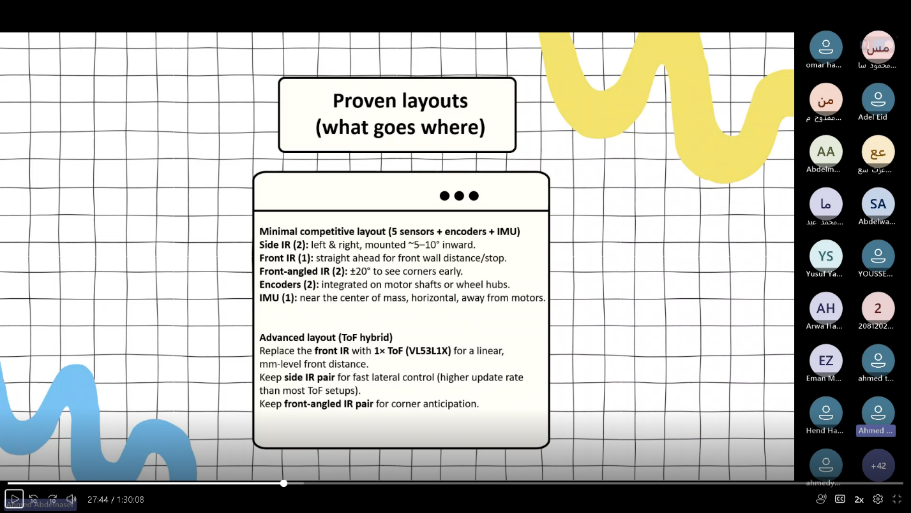With the proved layout:

# the motor:

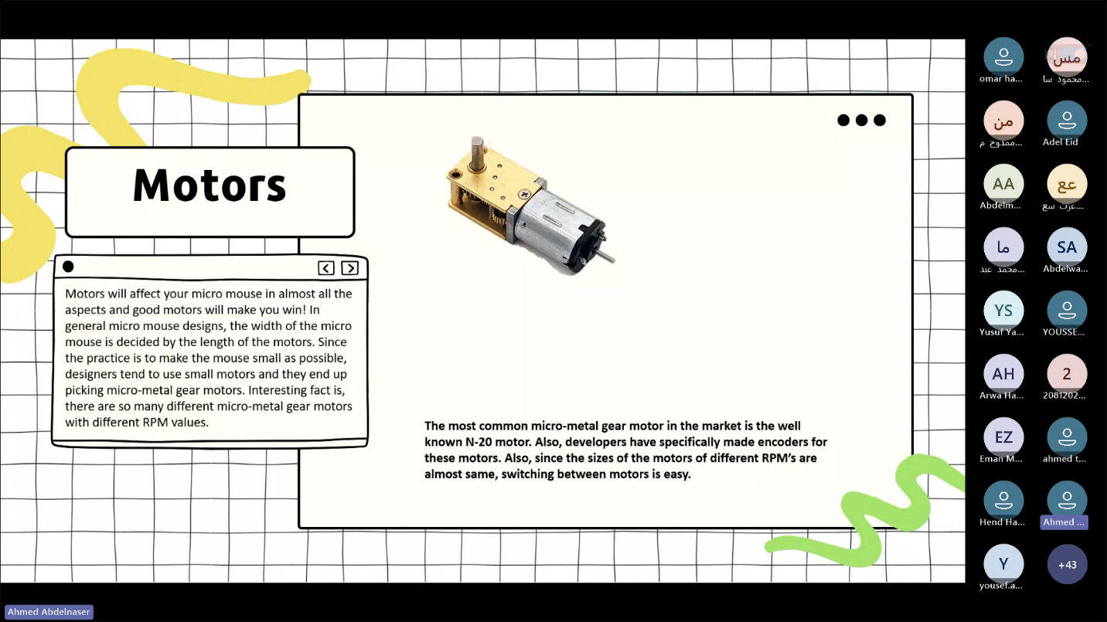We’ll use N-20 as it’s a light with understandable speed and torque

And it’s also equipped with encoder to control it.

So what we need to do is to figure out which gear ratio we’re gonna use in the gearbox assuring good RPM and speed.

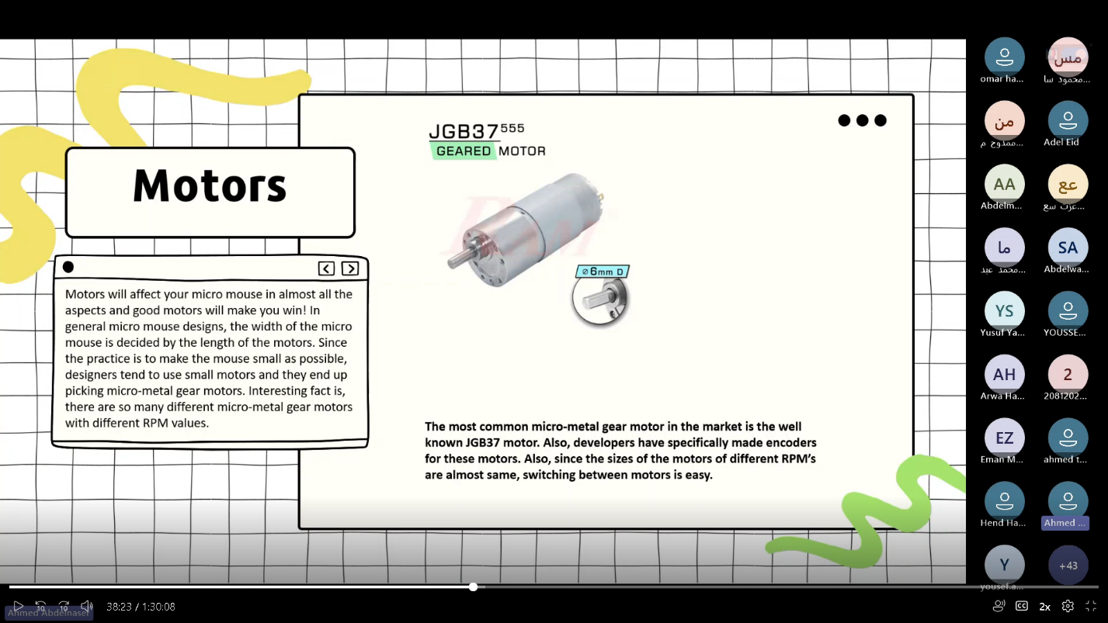There’s the upgraded N-20:

But considering that we’ll make a small robot we prefred N-20.

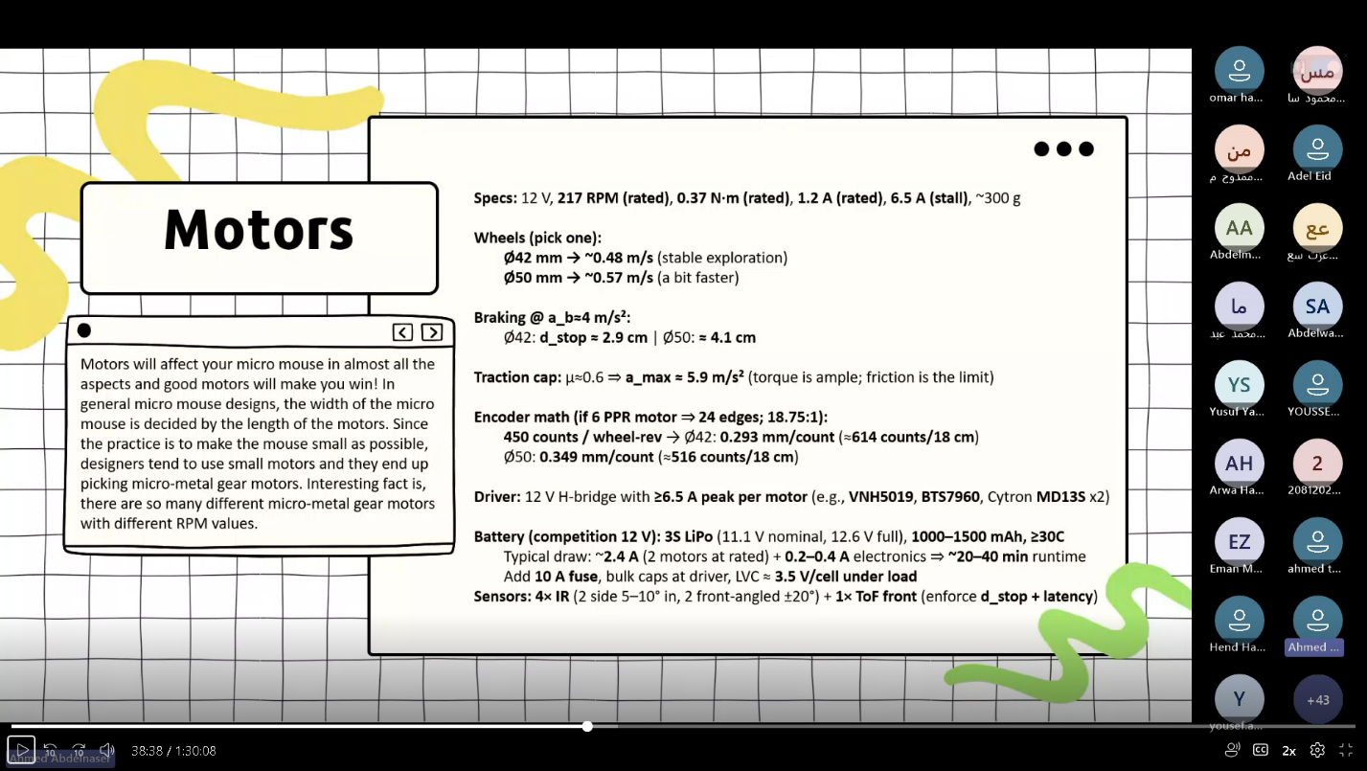For the motor calculations:

# the wheels:

Our robot is small that’s why we will use the differnitial configuration with an omni wheel for stability.

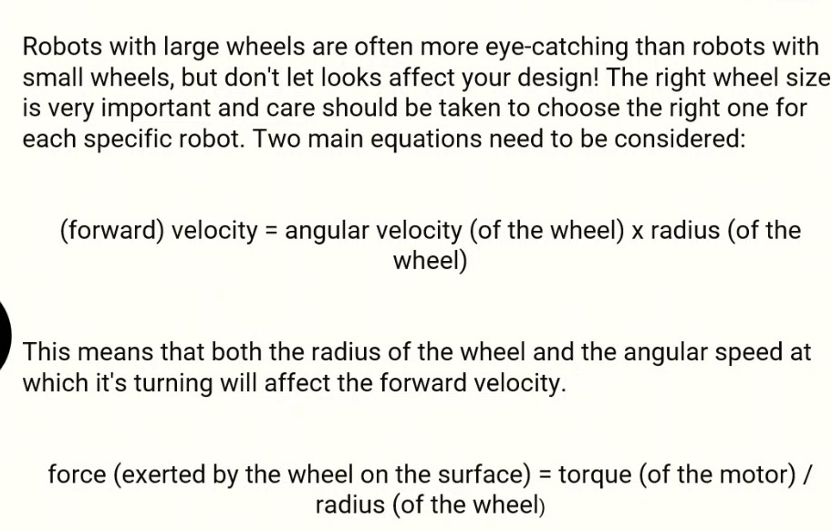As for the wheel calculations:

As for the wheel material we can’t have a smooth wheel because it has a little friction which will be unstable rather it’s preferred to use a rubber like wheel material.

# Body:

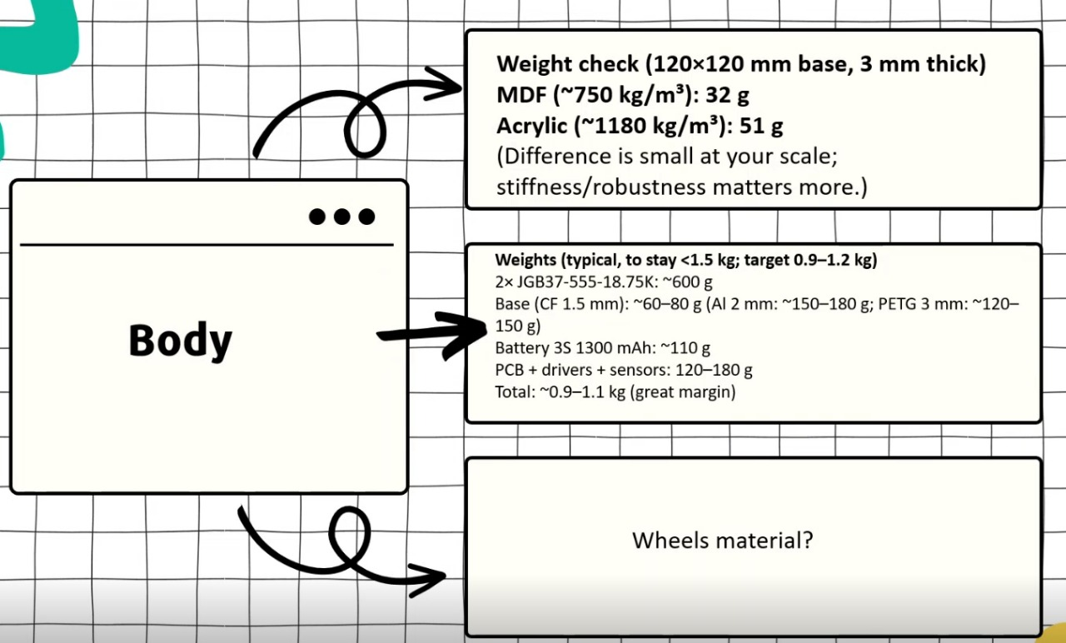As for the body it’s recommended to use acrylic as carbon fiber is not available in Egypt

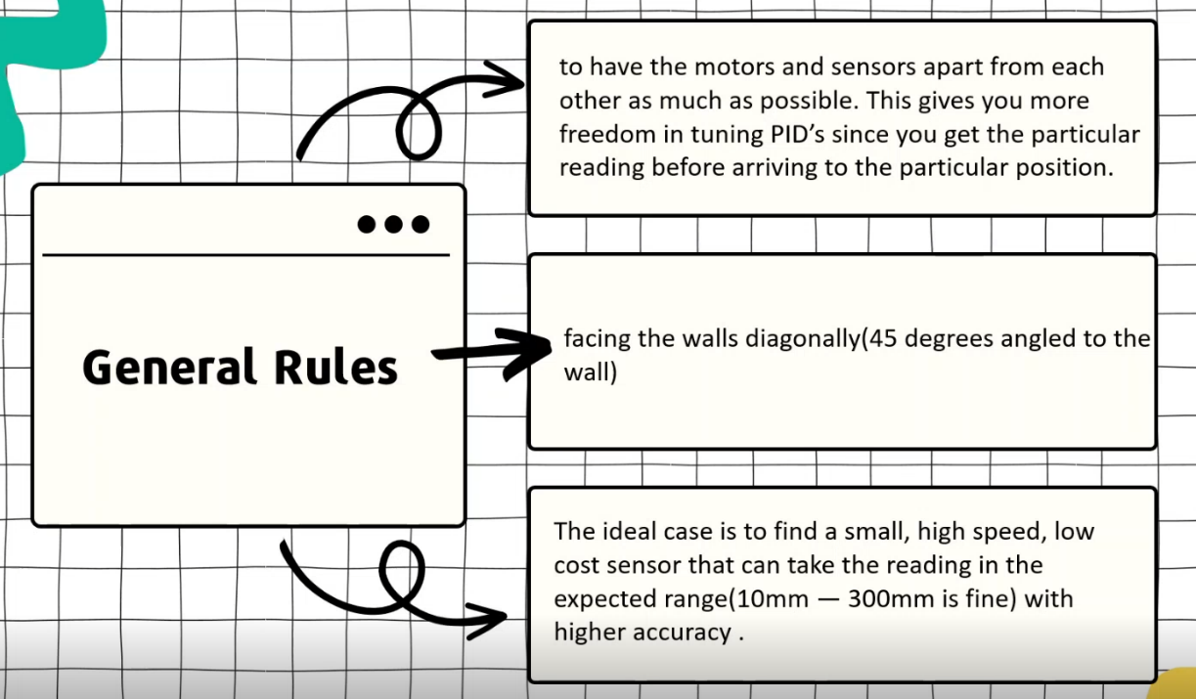With those general rules

# Battery:

We’ll use 3S 1300 mAh as it’s light and can provide the power needed for the robot.

The battery will be placed in the center of the robot

# Prototype